**Creating an App’s Navigation**

Creating an app's navigation is about crafting a seamless and intuitive journey for users. Navigation should prioritize simplicity, guiding users to their desired destinations with minimal effort. It’s essential to understand the target audience and design with their habits and preferences in mind, leveraging familiar patterns like tab bars, side menus, or floating actions to reduce the learning curve. Accessibility should be a core consideration, ensuring the app is usable for everyone, including those with disabilities. Consistency across screens is vital to avoid confusion, while progressive disclosure can help manage complexity by showing only what’s necessary at any given moment. Additionally, mobile-first design principles, such as thumb-friendly interfaces and minimal screen depth, are crucial for a smooth experience on small devices. Lastly, navigation design is an iterative process—real user feedback and analytics should shape improvements over time, ensuring the app continues to meet evolving user needs effectively.

**USING THE NAVIGATOR**

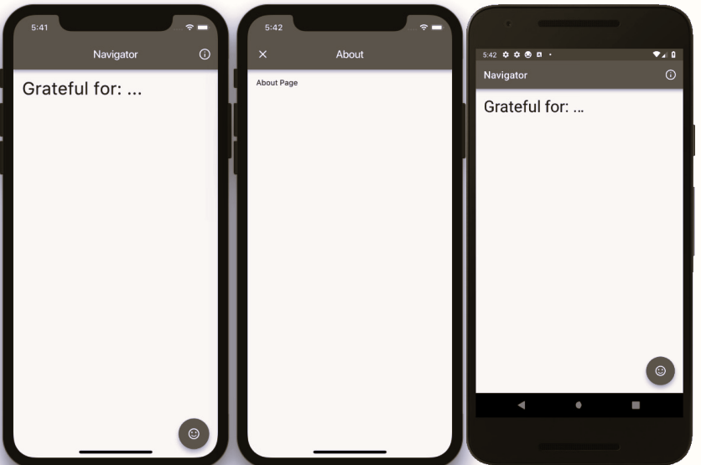

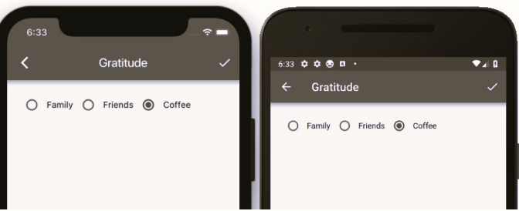

**USING HERO ANIMATION**

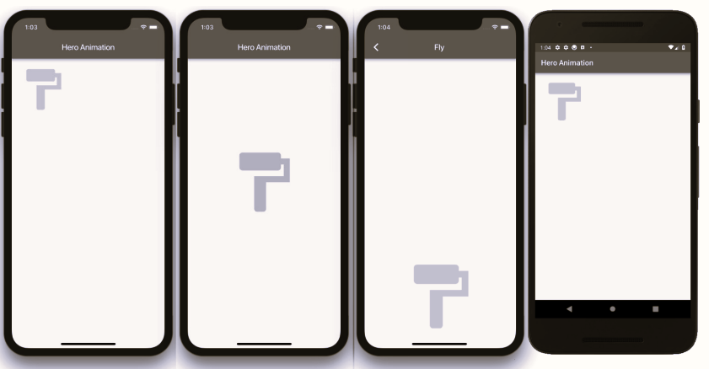

**USING THE BOTTOMNAVIGATIONBAR**

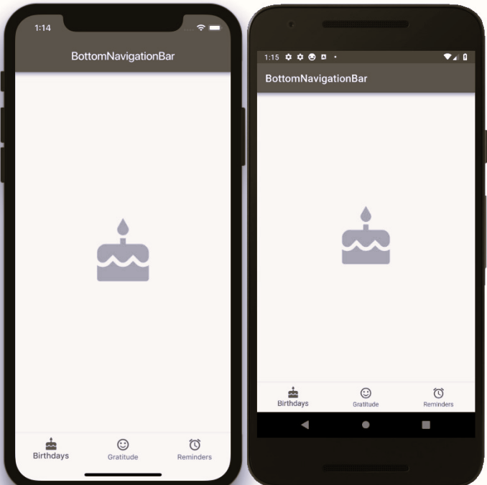

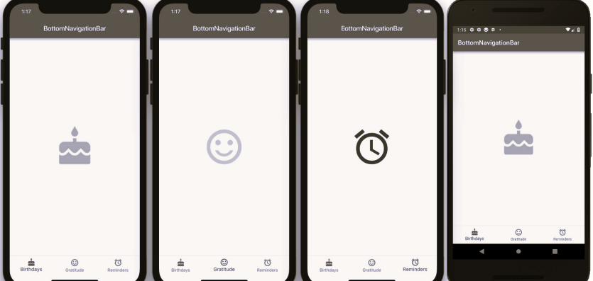

**USING THE BOTTOMAPPBAR**

